## Sequence Diagram

**Customer**

1. **Register**



This is the sequence diagram to present the user register system. The first, user request to register then the Account Controller will call Register() method to send customer information to the dependency injection ninject to save information to database with Account repository abstract.

1. **Log In**

This is the sequence diagram to present the customer Login system.The first, user  
request to login, then the Account Controller will call login method to get the username and password to verify with database and dependency injection ninject.

**3. Edit profile**



The sequence diagram presents function to edit profile. After user logged in to the web application, user can edit profile by request to edit profile. Account controller will call method to edit account in account repository.

**4. Add product to cart**



This is the sequence diagram to present the user add product to the cart. The first, user request to add product to class, then the Account Controller will call add to cart() method to add product to the dependency injection ninject to save adding product to database with Account repository abstract.

**5. Delete product from cart**



This is the sequence diagram to present the user add product to the cart. The first, user request to delete product to class, then the Account Controller will call remove from cart() method to delete line from the dependency injection ninject to delete product from database with Account repository abstract.

**Admin**

1. **Log in**

 This is the sequence diagram to present the admin login system.The first, admin  
request to login, then the Account Controller will call login method to get the username and password to verify with database and dependency injection ninject.

1. 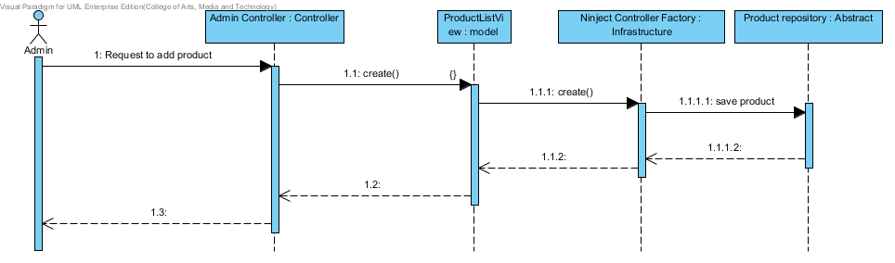**Add product**

This is the sequence diagram to present the admin add product to the system. The first, admin request to add product, then the Account Controller will call create() method to create product to the dependency injection ninject to save new product to database with Account repository abstract.

1. **Delete Product**



This is the sequence diagram to present the admin delete product to the system. The first, admin request to delete product, then the Account Controller will call delete() method to delete product from the dependency injection ninject delete product from database with Account repository abstract.

1. **Edit Product**



This is the sequence diagram to present the admin edit product in the system. The first, admin request to update product, then the Account Controller will call edit() method to edit product to the dependency injection ninject, then it will save updating product to database with Account repository abstract.

1. **History**

